- Home
- Process
- Collections
- About
- Workshops
- Location
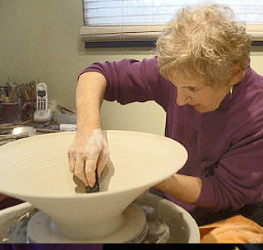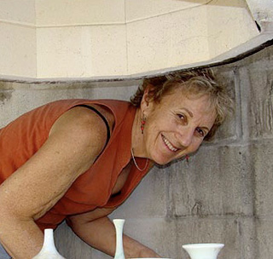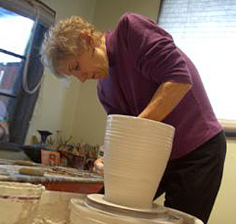
My Work
I walked into a pottery studio in Ann Arbor, Michigan in 1969 and sat down at a potters wheel to try to turn a spinning lump of clay into a bowl, a side road from an academic path that turned into a lifelong passion.... the clay, making pots, being a potter. It grabbed me! I started making stoneware pieces: sturdy, earthy and functional, they spoke to both the ancestral and timeless beauty of clay forms.
But within six years, I turned my attention to porcelain, finding the greater movement (plasticity) of the clay and the increased translucency of its glazes both challenging and enthralling. I began altering the porcelain forms as my throwing developed, making the pieces more personal and more interesting, eventually creating a specific look that, fifty years later, continues to develop: fluid, delicate forms enhanced by striking, vibrant glazes.
This being a constant, my work has evolved in numerous ways over the decades. In the 80s, I spent many years mastering airbrush techniques on both my porcelain pieces and on large-scale tile wall murals, (which offered me a larger canvas) , focusing on nature and landscapes, spraying the glazes to allow subtle color blends.
Then, in the mid 90s, my work underwent perhaps its biggest transformation. In 1991, the Auckland, New Zealand potters invited me to teach a workshop. Since then I have taught workshops for a month or two every couple of years in Australia, New Zealand and, more recently, in Thailand.
And when, in 1996, I found a small crystalline plate at a gallery in Adelaide, Australia, I returned home ready to start the crystalline experimenting I'd thought about for years: with glazes formulas and firing schedules, with different colorant combinations, and with different kilns. Ever since, I have been working exclusively with crystalline glazes, always looking forward to opening the next kiln.
I continue to make frequent trips to Southest Asia as my ties with the artist communities strengthen. I will return in 2019 to visit Australia and teach in Bali.
I'm so happy to have walked into that pottery studio in 1969, thankful for the potters who have mentored and encouraged me along the way, and grateful for the people who have bought my work over the years, supporting the shifts and changes in color and form and allowing me the gift of pursuing the potters life

